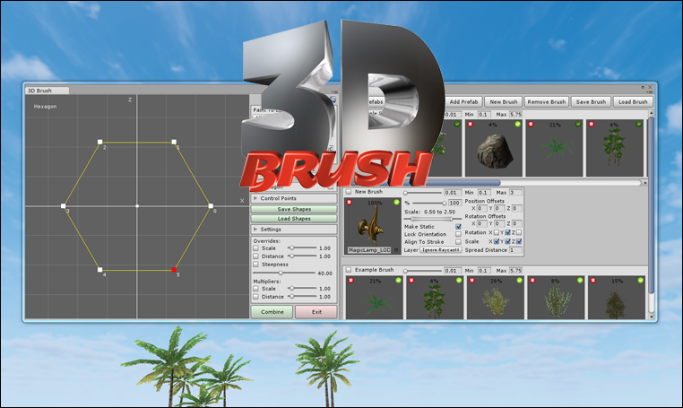

Starting 3D Brush

After importing the package you will notice a new folder called 3D Brush has been added to the project window. To open the 3D Brush window click on the Window menu item in Unity, hover the mouse over the 3D Brush item and then click on Open Window. The 3D Brush window is tabbed so you can dock the window by clicking on its tab and dragging it next to the other windows.

If you need a quick guide to using 3D Brush while in Unity you can click on the help button at the top right of the 3D Brush window.

About 3D Brush

There are two main windows which are docked one behind the other. The first window that you see is the main interface where you can set things like the brush size and override the brush settings. It is also the window you use to create custom shapes which can then be used as stencils for painting. The other window is the Brushes window which is docked next to the main window and can be accessed by clicking on its tab. The key features of the program are the Brushes, Prefabs and Shapes. Each feature plays a part in how the painting of prefabs is performed and what the final effect will look like.

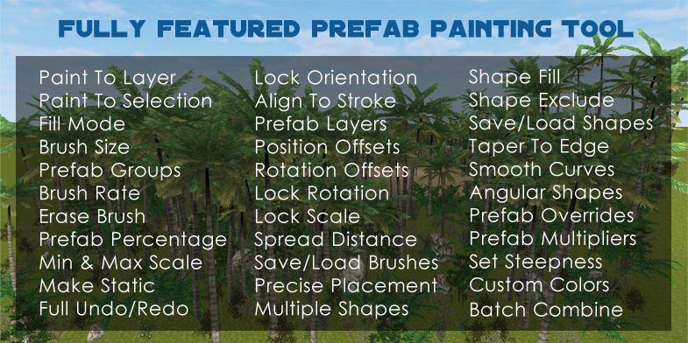

Getting Started

To start painting just hold down the hotkey and left click on any object that has a collider attached or click on the terrain. The default hotkeys are the left or right Ctrl keys but you can change these in the settings area which is covered later. The example brush is a collection of eight prefabs which include a palm tree, bushes and a rock. These prefabs come from the standard terrain assets and two free asset packs provided by Unity Technologies on the Asset Store. You can find links to these assets at the end of this tutorial.

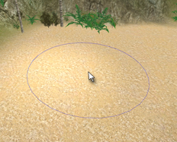
When the hotkey is pressed and you move the mouse over an object or the terrain you will see a circular cursor is displayed in the scene view. To change the size of the brush you can use the slider to set the Brush Size near the top right of the main window or you can hold down the shift key and scroll the mouse wheel.

All prefabs that are painted to the scene will be parented to a new group object which is created with the Group Name title. To create a new group simply enter a new name in the text box before painting.

To delete the prefabs, press and hold down the shift key while clicking and dragging in the scene view. Only prefabs that are in the current group will be deleted.

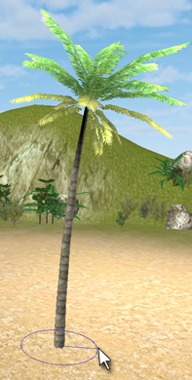
You can also add a single prefab and adjust its scale and rotation at the same time. To do this start by pointing the mouse where you would like to place the prefab and then right clicking and dragging while holding down the hotkey. As you hold down the button and move the mouse the prefab will scale and rotate automatically and keep those settings when you release the button. The prefab that is chosen is the first active prefab in the currently selected brush.

You can undo and redo any painting or deleting actions by using the Ctrl-Z and Ctrl-Y shortcuts.

Main Window

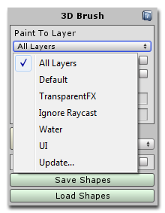
At the top of the main window is a drop down list for selecting which layer to paint the prefabs to. By default it is set to All Layers but if you wanted to just paint to the terrain then you can select it here.

Below this is a checkbox called Paint To Selection which forces the program to only paint onto the selected objects. This feature overrides the Paint To Layer setting.

If Fill Mode is checked then the brush will continue to paint while the left mouse button is down. Otherwise it will only paint when the mouse is clicked or moving. Next we have the Brush Size slider and Group Name field as mentioned above.

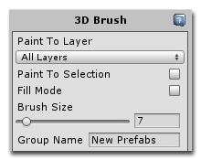
I will discuss the shapes, control points and settings in detail later and will just give an overview here. The shapes are used to define areas that restrict the painting of prefabs. You can use multiple shapes at a time and, depending on their type, a shape can either be used as a stencil to constrain the painting of prefabs to a certain area or to prevent painting in an area. The shapes are fully customizable and they can be angular or smoothly curved depending on the types of points used.

I will also cover the 2D interface, Overrides and Multipliers once we have covered the brushes and prefabs.

Brushes

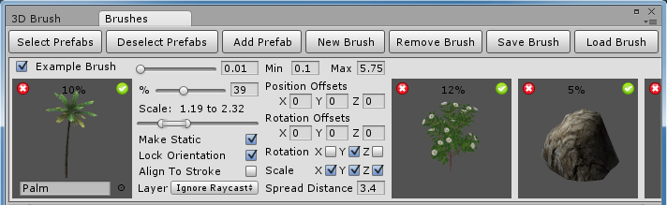

To view the brushes click on the Brushes tab and you will see all of the available brushes. Only one brush can be active at a time and you can see that the example brush is the active brush because the checkbox next to its name is ticked.

Next to the brush name there is a slider which controls how fast the brush will paint. If you would like to slow the brush rate then move this slider to the right. Next to this slider are two fields which set the minimum and maximum values for the scale slider.

The brushes are made up of multiple prefabs, each of which are shown as thumbnails. You can select which prefab you want to change the settings for by clicking on its thumbnail.

Clicking on the New Brush button at the top of the window will add an empty brush to the window and clicking on the Remove Brush button will remove the currently selected brush.

At any time you can save the selected brush to an XML file by clicking on the Save Brush button and by default they are saved in a folder called Brushes in the main program folder. When the program starts it loads all of the brushes located in a subfolder called Start Brushes in the Brushes folder. If you save your brushes to this folder they will be loaded each time the program is started. Clicking on the Load Brush will load the selected file and add the brush to the list of brushes.

To add a prefab to the selected brush click on the Add Prefab button at the top of window and it will be added to the end of the brush. Another way to add prefabs is to selected them in the project and drag and drop them onto the brush where they will be added to the end of the brush.

Prefabs

On the thumbnail image of each prefab you will see a red cross and green tick. Clicking on the cross removes the prefab from the brush and clicking on the tick will activate or deactivate the prefab. To activate all of the prefabs in the brush click on the first button called Select Prefabs at the top of the window. The Deselect Prefabs button will deactivate all of the prefabs at once. This is useful when you want to set a single prefab as active. Simply deactivate all of the prefabs, click on the tick mark for the prefab you want to place and use the middle mouse button to place it in the scene.

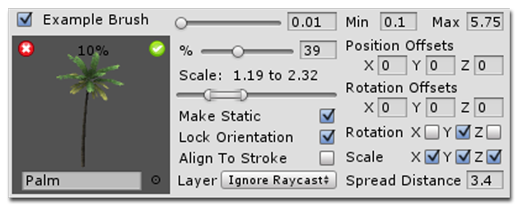

Just above the picture of the prefab is the probability percentage that this prefab will be chosen while painting. You can turn this up or down by moving the slider located just below the brush rate slider. As this value increases or decreases the probability of all other prefabs will decrease or increase respectively.

Also within the thumbnail image area you can click on the object selection control to pick a different prefab from the game object selection window.

Below the percentage slider is the scale slider. This split slider allows you to set the minimum and maximum scale that will be randomly applied to the prefab when it is placed in the scene. If you move the minimum and maximum positions together you can set the exact scale of the prefab.

Following this are checkboxes to set whether the prefab is to be made static when painted to the scene, whether to lock its orientation so that it doesn't align to the surface and whether it will align to the brush stroke as the mouse moves across the surface of the object being painted.

And just below these checkboxes is a drop down list to select the layer to paint the object to. By default this is set to Ignore Raycast so that the prefabs don't pile on top of each other while being painted. If the selected prefab doesn't have a collider then this isn't an issue and you can set the prefab to any layer you want.

To the right of the percentage slider are two vector fields to set the starting position and rotation offsets. If the prefab needs to raised to be above the surface being painted on or needs to be rotated to an upright position then enter the default values here.
Next are the rotation and scale selectors. If a checkbox is ticked then a random rotation or scale will be applied on that axis to the painted prefab.

Lastly is the spread distance. This allows you to set the minimum distance between this prefab and any other prefabs being painted and is useful for preventing overdraw where multiple prefabs are placed at the same location. The general rule is that the larger the object the larger the spread distance.

Overrides and Multipliers
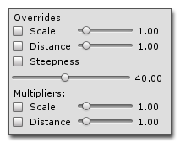
Now that you know about the different prefab settings you will have a clearer idea of what these settings do. By ticking the checkboxes for each override you can force the program to ignore the scale or distance settings for each prefab.

The steepness override only works with the terrain object. It prevents the program from painting prefabs in areas of the terrain that are steeper than the given angle. This is useful when painting around steep areas where you don't want trees and bushes sticking out of the cliff faces.

If checked, the multipliers modify the prefab settings to increase or decrease the overall brush scale and distances.

Shapes

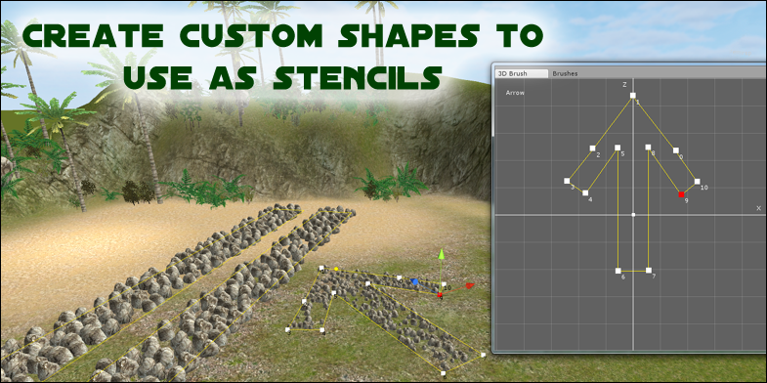

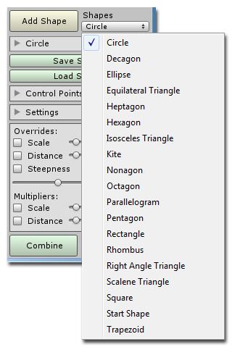
When the program starts there is only one shape which is currently not visible in the scene view. To make it visible click on the checkbox to the right of its name in the shapes list. You can select from many different shapes by clicking on the Shapes drop down list and choosing a new shape before clicking on the Add Shape button. When any shape is selected you can only paint within the bounds of that shape. The brush cursor will appear when you hold down the hotkey and mouse over the shape. See the section called 3D Brush Object below for direction on placing and moving shapes in the scene view.

Shapes List

When you click on the Add Shape button the new shapes will be added to the shapes list just below this button. You can select a shape to work on by clicking on its entry in the list. You can change the order of the shapes by clicking on a shape in the list and dragging it up or down though this serves no real purpose for now. A future version will determine whether a prefab is painted or not based on the order of the shapes. A green line will highlight where in the shapes list it will be placed when you release the mouse button.

You can also expand an entry in the list by clicking on its arrow to show the shape's settings.

Shape Settings

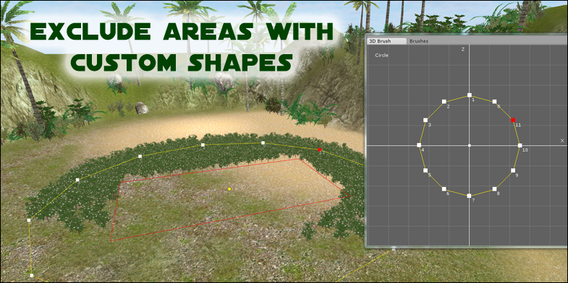

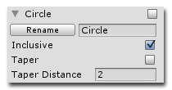
To rename a shape simply enter a new name in the text box and then click on the Rename button.
You can also set whether the shape is to be inclusive or exclusive by ticking or un-ticking its checkbox. An inclusive shape will constrain the painting of prefabs to the boundaries of that shape and is shown in yellow in the scene by default.

As mentioned before, if a shape is selected, the brush cursor will only appear when it is over an inclusive shape. If a shape is not ticked as being inclusive it is then exclusive and will prevent painting within its bounds. An exclusive shape is shown in red in the scene view by default.

If the Taper checkbox is ticked then the prefabs painted on the shape will taper off to a scale of zero the closer they are to the edges of the current shape. The distance this begins from is set by the Taper Distance. This is useful for grass prefabs being painted next to paths or around poles, etc. This is an experimental feature and it will be fully realized in a future version of 3D Brush. It should have new settings to set the minimum and maximum taper as well as use a curve rather than a linear taper.

Saving and Loading Shapes

At any time you can save the shapes to file or load a previously saved file. By default the shapes will be saved in the folder called Shapes in the main program folder. They are saved as XML files and can be shared with anybody else that is running 3D Brush. If you want your new shapes to be added to the drop down list of starting shapes then save it in the Shapes/Primitives folder instead and it will be accessible the next time you open 3D Brush. By default the starting shape is a circle but if you save your new shape in the Shapes/Primitives folder and call it Start Shape then it will be the first shape to load.

Context Menu

By right clicking on a shape in the list a context menu will open where you can choose to copy, paste or delete a shape. Once you have copied a shape you can paste it back in the list by right clicking on a shape to open the context menu again and choosing paste. It will be added to the list after the entry you clicked on.

To copy or delete multiple shapes at a time first tick the shapes in the list before bringing up the context menu. You can also Select All or Deselect All from the context menu to automatically tick or un-tick all of the entries in the list.
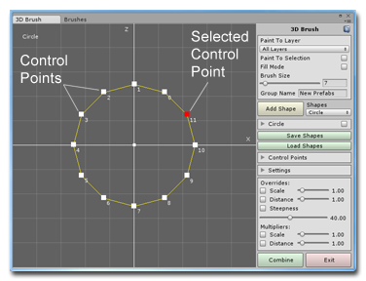
2D Interface

To the left of the main menu area is the 2D interface with a top down view of the currently selected shape. To change which shape is currently selected click on its name in the shapes list. You can move around in the 2D window by right clicking anywhere on this view and dragging the mouse. You can also zoom in and out by rotating the mouse wheel forwards and backwards.

Working with Control Points

To change the shape, left click and drag any of the white control points in the 2D window and you will notice that the shape in the scene view also changes. When a control point is selected it will turn red and the corresponding point in the scene view will also turn red and has a move handle attached to it. If you move a point in the scene view then the 2D window will also update.

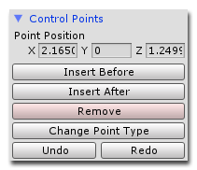
When working with the control points you can access more features by expanding the Control Points section. In this section you can explicitly set the position of a control point by entering the coordinates for in the Point Position fields. A quick shortcut is to click on the X, Y or Z labels and drag the mouse left and right to change the values.

Below the Point Position you can click on the buttons to insert a point before the selected point, insert a point after the selected point or remove the selected point altogether.

You can also click on the Change Point Type button to toggle between points that make a sharp corner and points that make a curved corner. The Undo and Redo buttons will undo and redo any point movements but not for changes to the position, rotation or scale of the 3D Brush object and shapes, for these use the Unity undo and redo shortcuts.

3D Brush Object

When 3D Brush starts it automatically creates a new game object called 3D Brush which you will see has been added to the hierarchy window. This object is the parent of any shapes that have added to the list just below the Add Shape button. When you select and move this object all of the shapes will move with it.

You can move both the parent object or the shapes by selecting them in the hierarchy and moving them using the handles in the scene view. A quicker way to move all of the objects together is to double click on an object or the terrain.

You will also notice that there is a small yellow sphere located at the center of the shape. This is the position of the 3D Brush object's pivot point. If you move the 3D Brush object then the pivot point will also move but if you move the shape the pivot point will remain unchanged. This is a good way to tell if you've accidentally moved one when you meant to move the other.

Both the 3D Brush object and the shapes can be translated, rotated and scaled like any other game object. However, the 2D view of the shapes will not show any change as it represents a local view of the shapes rather than a world view. If you want to transform the entire group of shapes you can do this by selecting the 3D Brush object in the hierarchy and then moving, rotating or scaling as normal. Any parented shapes will change relative to the 3D Brush.
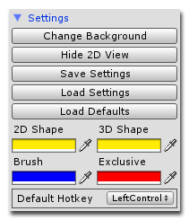
Settings

To access the settings menu click on the small arrow next to the Settings label and the box will expand.

In this menu you can click on the Change Background button to select a JPEG or PNG image which enables you to trace images of real world objects.

To make working in the scene view easier you can also click on the Show/Hide 2D View buttons. You can also Save and Load the current settings which includes all colors. If you need to go back to the original configuration click on the Load Defaults button.

If you find you need to change the default colors for the 2D or 3D views to work with a certain background color or scene then you can also do that in this section as well.

You can change the default hotkey used by the program by selecting a new key to use from the drop down menu at the bottom of the settings.

Combine

The combine button at the bottom of the main window batches all of the static objects in the current group to reduce the number of draw calls. One important point to remember is that objects with different scale values cannot be batched together so the saving here will not be as high as expected if you are painting with random scale values.

Example Assets

The example assets used with this program and many more are available for free from
Unity Technologies at the following locations:

Standard Terrain Assets
Available in Unity by clicking on the Assets menu item and going to Import Package/Terrain Assets.
Terrain Assets
https://www.assetstore.unity3d.com/en/#!/content/6

Shanty Town: Brush Vegetation
https://www.assetstore.unity3d.com/en/#!/content/41

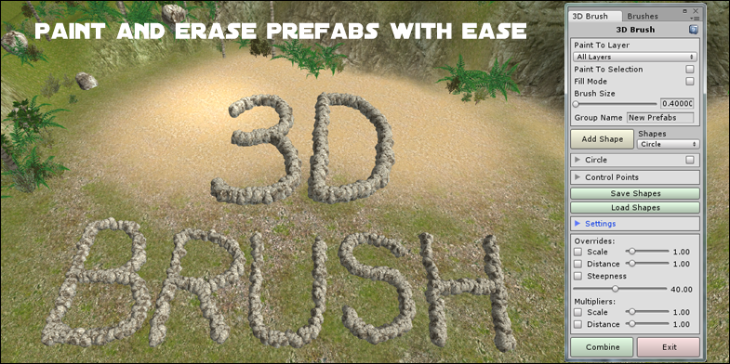
Notes

In Unity 5 it is recommended to turn of continuous baking of lightmaps by going to the menu and navigating to Window/Lighting/Lightmaps and unchecking the checkbox. This will prevent lag and stuttering in the editor.

To learn more about 3D Brush and to view the tutorial videos you can visit
MeshMaker.com

